**Fitness Trainer Appointment Scheduling Website**

Welcome to the front-end part of the Fitness Trainer Appointment Scheduling Website. This web application allows fitness trainers to efficiently manage appointments for their clients. The user-friendly interface allows trainers to add, edit, and delete appointments, along with client details.

**Table of Contents**

1. [Introduction](https://chat.openai.com/c/4b3dbc7b-f5d3-4b84-8d46-86e05bf22541#introduction)
2. [Installation](https://chat.openai.com/c/4b3dbc7b-f5d3-4b84-8d46-86e05bf22541#installation)
3. [Usage](https://chat.openai.com/c/4b3dbc7b-f5d3-4b84-8d46-86e05bf22541#usage)
4. [Screenshots](https://chat.openai.com/c/4b3dbc7b-f5d3-4b84-8d46-86e05bf22541#screenshots)
5. [Calendar Feature](https://chat.openai.com/c/4b3dbc7b-f5d3-4b84-8d46-86e05bf22541#calendar-feature)
6. [Technology Stack](https://chat.openai.com/c/4b3dbc7b-f5d3-4b84-8d46-86e05bf22541#technology-stack)
7. [Acknowledgments](https://chat.openai.com/c/4b3dbc7b-f5d3-4b84-8d46-86e05bf22541#acknowledgments)

**Introduction**

The website features a clean and intuitive grid layout where each row corresponds to a different client. Trainers can easily edit client details, add new appointments, edit existing appointments, and delete appointments. The user interface provides a responsive and modern design, ensuring a smooth user experience.

**Installation**

To run the project locally, follow these steps:

1. Clone the repository:

* git clone https://github.com/preet-codes/[ENTNT-Assignment](https://github.com/preet-codes/ENTNT-Assignment).git

1. Navigate to the project directory:

* cd fitness-trainer-appointment-scheduler

1. Install dependencies:

* npm install

**Usage**

Run the project in your Angular environment using the following command:

* ng serve -o

This will open the project in your default web browser.

**Screenshots**

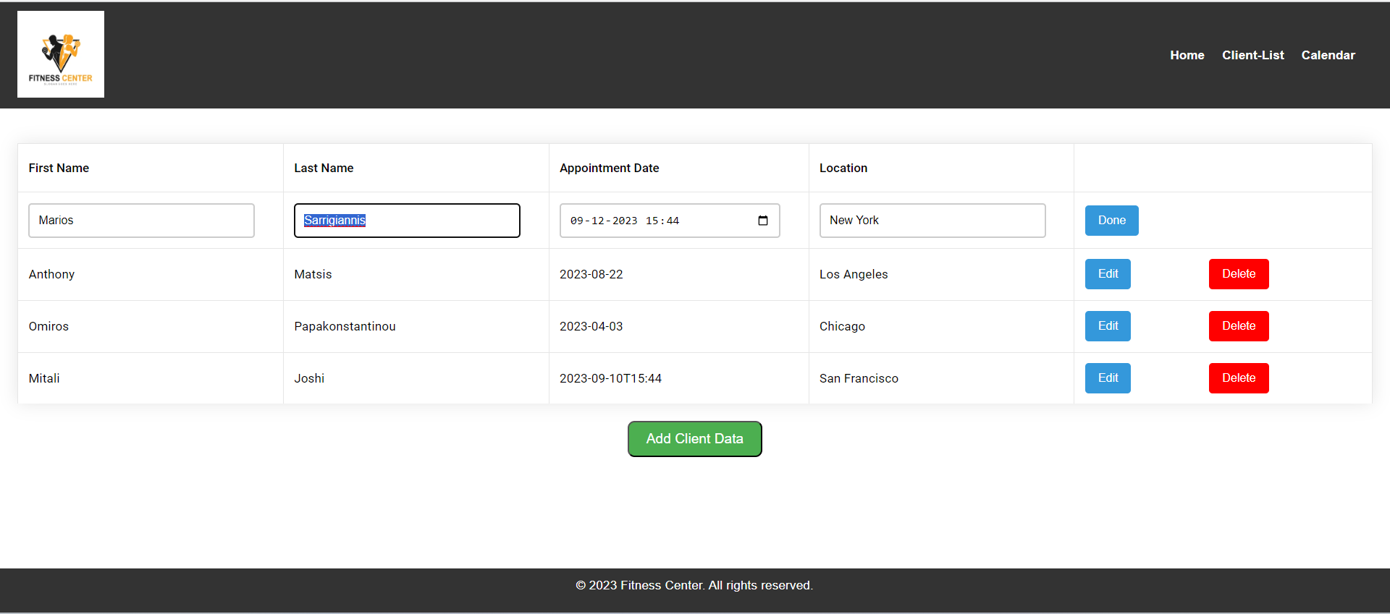

**Calendar Feature**

Please note that the calendar feature is a bonus assignment and, due to time constraints, could not be implemented. You can explore and extend this feature based on your preferences.

**Technology Stack**

The front-end of this application is built using Angular, providing a robust and scalable foundation for web applications.

**Acknowledgments**

This project is a demo frontend of the Fitness Trainer Appointment Scheduling Website. Due to the absence of a server for deployment, the website is intended for local use. Feel free to explore, modify, and extend the functionality based on your requirements.

Cheers!